Using the Four-Door Foldable  Grammar Application  Use this foldable for information occurring in four categories. Have students create study guides and review grammar concepts such as four types of sentences. They may label each door with a type of sentence, then define each type and provide an example inside each door.  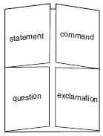  Comprehension Application  When students are reading a selection, they can use the Foldable to record and store information for summarizing. Have students write descriptions and include illustrations inside the four doors. Guide them to choose four categories of information. For example:  - Who, what, when where  - What, where, when, why/how  - Character, plot, setting, conflict and resolution  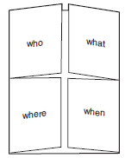 | Four-Door Foldable Directions  Materials:  - Sheet of 11” x 17” paper  - Scissors  Directions:  - Make a shutter fold.  - Fold the shutter fold in half like a hamburger. Crease well.  - Open the folds and cut along the inside valley fold lines.  - These cuts will form four doors on the inside of the book.  Use this Foldable to _________________________________________  _________________________________________________________  _________________________________________________________  _________________________________________________________

